Try these!!!

$\frac{8}{8}=$ $\frac{32}{32}=$

$\frac{0}{8}= ____$ $\frac{-32}{-32}=$

$$\frac{2}{10}+\frac{8}{10}= \frac{ }{10}= _____$$

$$\frac{6}{6}+ \frac{0}{47}= ______$$

$\frac{0}{12}+ \frac{0}{9} + \frac{10}{10}$_____ _____

___

= ___

OKAY now for some real subtraction!

1 – $\frac{1}{3}$… change the 1 to 3/3 and then take 1/3 away. 😊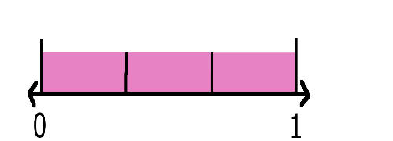

So $\frac{3}{3}-\frac{1}{3}=\frac{2}{3}$‘

Try these!

1 – ¼ = 1 – ½ = _____

1 – 2/3 = ¾ - 2/4 = _____

Let’s mix things up 😊

¾ + ¼ = _____ = _____ 1/3 + 1/3 = _________

1 – 1/6 = ___________ 1 – 1/7 = ___________

5/6 - 2/6 = _________ 1 – 3/8 = ______________

Try these!!!

$\frac{8}{8}=$__1 $\frac{32}{32}=$__ __1

$\frac{0}{8}= _0___$ $\frac{-32}{-32}=$___

__1

$$\frac{2}{10}+\frac{8}{10}= \frac{ 10}{10}= ___1__$$



$$\frac{6}{6}+ \frac{0}{7}= 1+0=1$$



$\frac{0}{12}+ \frac{0}{9} + \frac{10}{10}$_

= 0 + 0 + 1 = 1___

OKAY now for some real subtraction!

1 – $\frac{1}{3}$… change the 1 to 3/3 and then take 1/3 away. 😊

So $\frac{3}{3}-\frac{1}{3}=\frac{2}{3}$‘

Try these!

1 – ¼ = 4/4 – ¼ = ¾ 1 – ½ = _ ½ ____

1 – 2/3 = 1/3 ¾ - 2/4 = __1/4___

Let’s mix things up 😊

¾ + ¼ = _4/4__ = _1____ 1/3 + 1/3 = 2/3_______

1 – 1/6 = $\frac{6}{6}-\frac{1}{6}=\frac{5}{6}$___ __ 1 – 1/7 = $\frac{7}{7}-\frac{1}{7}=\frac{6}{7}$

_

5/6 - 2/6 = ___3/6____ 1 – 3/8 = _5/8