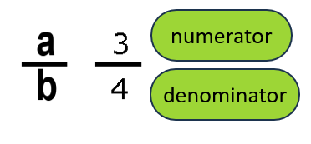 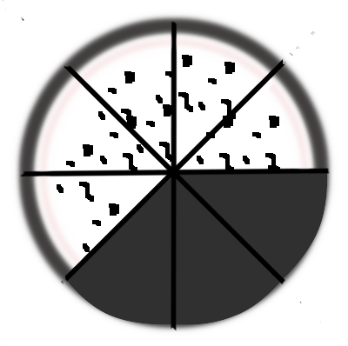

$\frac{a}{a}=1$ $\frac{-a}{-a}=1$ $\frac{0}{a}=0$ $1-\frac{3}{8}=\frac{8}{8}-\frac{3}{8}=\frac{5}{8}$

Try these!!!

$\frac{9}{9}-\frac{4}{9} =$ $1-\frac{2}{8}=$

$1- \frac{1}{8}= ____$ $1-\frac{3}{8}=$

$$\frac{2}{5}+\frac{3}{5}= \frac{ }{5}= _____$$

$$\frac{5}{5}+ \frac{13}{13}= ______$$

$\frac{0}{12}+ \frac{9}{9} + \frac{20}{20}$_____ _____

___

=

$\frac{a}{a}=1$ $\frac{-a}{-a}=1$ $\frac{0}{a}=0$ $1-\frac{3}{8}=\frac{8}{8}-\frac{3}{8}=\frac{5}{8}$

___

 

Try these!!!

$\frac{9}{9}-\frac{4}{9} =$ $\frac{5}{9}$ $1-\frac{2}{8}=$ $\frac{6}{8}$

$1- \frac{1}{8}= \frac{7}{8}$ $1-\frac{3}{8}=\frac{5}{8}$

$$\frac{2}{5}+\frac{3}{5}= \frac{5 }{5}= 1$$

$$\frac{5}{5}+ \frac{13}{13}= 1+1=2$$

$\frac{0}{12}+ \frac{9}{9} + \frac{20}{20}$ = 0 + 1 + 1 = 2