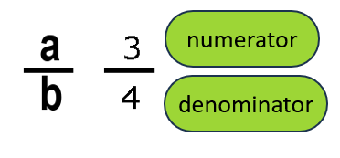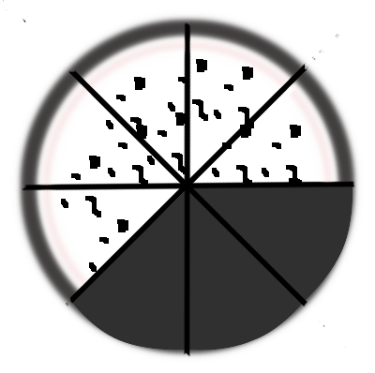
$\frac{a}{a}=1$ $\frac{-a}{-a}=1$ $\frac{0}{a}=0$ $\frac{3}{8}+\frac{5}{8}=\frac{8}{8}=1$

A whole.
$\frac{9}{9}=$_____ $\frac{312}{312}=$_____
$\frac{0}{17}= ____$ $\frac{-312}{-312}=$___
$$\frac{2}{5}+\frac{3}{5}= \frac{ }{5}= _____$$
$$\frac{5}{5}+ \frac{13}{13}= ______$$
$\frac{0}{12}+ \frac{0}{9} + \frac{20}{20}$ = ___
$\frac{a}{a}=1$ $\frac{-a}{-a}=1$ $\frac{0}{a}=0$ $\frac{3}{8}+\frac{5}{8}=\frac{8}{8}=1$

A whole.
$\frac{9}{9}=$__1___ $\frac{312}{312}=$__1___
$\frac{0}{17}= __0__$ $\frac{-312}{-312}=$_1__
negative divided by negative is positive
$$\frac{2}{5}+\frac{3}{5}= \frac{5 }{5}= ___1__$$
$$\frac{5}{5}+ \frac{13}{13}= 1+1=2 _____$$
$\frac{0}{12}+ \frac{0}{9} + \frac{20}{20}$ = __0 + 0 + 1 = 1_

