Section 3.2 A Whole
In the last section we learned that $\frac{a}{a}=1$ and $\frac{-a}{-a}=1$.
This is such an important fraction that it needs its own section!
If you have a whole pizza, you have 1 pizza. If it’s cut into 8 equal parts, you have $\frac{8}{8}$ of a pizza. But you also have 1 pizza. Same idea – different way of thinking about it. That’s math
Example 1
If you have a whole cake, you have _____(a number) whole cake. If it is cut into 8 equal pieces, you still have a whole cake, but we could say we have $\frac{8}{8}$ of a cake. $\frac{8}{8}$ = 1.
Also notice: each piece of cake is $\frac{1}{8}$ of the cake. So
$$\frac{1}{8}+\frac{1}{8}+\frac{1}{8}+\frac{1}{8}+\frac{1}{8}+\frac{1}{8}+\frac{1}{8}+\frac{1}{8}=1$$

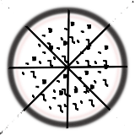
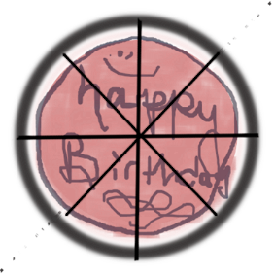
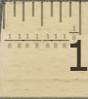
Example 2
If you have a rectangle, you have ____ (a number) rectangle. If you divide it into 6 equal pieces, you have $\frac{6}{6}$ of a rectangle. $\frac{6}{6}=1$
The parts add up to the whole.

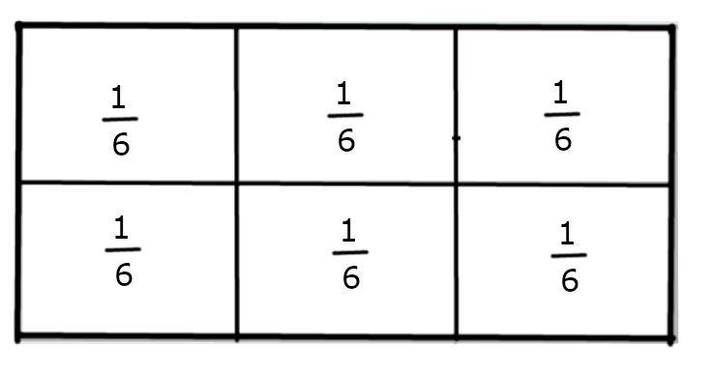
$$\frac{1}{6}+\frac{1}{6}+\frac{1}{6}+\frac{1}{6}+\frac{1}{6}+\frac{1}{6} = \frac{6}{6} = 1$$
Example 3

The picture below shows what’s left of a chocolate bar. The bar had 8 pieces of chocolate before some of it was eaten.

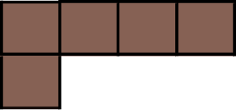
PART + PART = WHOLE
Fractional part eaten + fractional part not eaten = Whole Candy Bar

___________ + __________ = ___________
You draw it!
Add each of the following. Illustrate (draw) at least two of them. Your pictures can be different shapes; the pieces have to be the same size.
- $\frac{1}{4}+\frac{3}{4}$

- $\frac{3}{10}+\frac{7}{10}$

- $\frac{4}{10}+\frac{6}{10}$

- $\frac{1}{5}+\frac{1}{5}+\frac{1}{5}+\frac{1}{5}+\frac{1}{5}$

A part added to a part builds a whole.
Part + part = whole. 
Part + Part = ONE WHOLE
with without PIZZA
mushrooms
½ + ½ = 1 or $\frac{2}{2}$
Different ways of talking about the same amount.
Let’s level up!!!
Another way of looking at parts and wholes is:
Whole minus part = part. 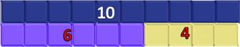
So, with whole numbers, 10 – 4 = 6
10 – 6 = 4
If we know what the whole thing is and what one part is, we can subtract to find the other part. It works for fractions too!
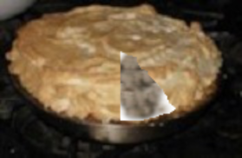
A whole pie is 1 pie. I’m going to slice my pie into 7 even pieces. I’m talented :P
If I eat one slice, how many are left? What fraction shows that amount?

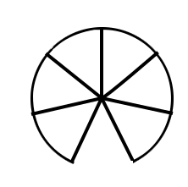
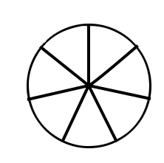
1 - $\frac{1}{7}$ is equivalent to
$$\frac{7}{7} -\frac{1}{7}$$
Which leaves me with $\frac{6}{7}$ of my 1 whole pie left.

BIG IDEA: Substitution
I can’t subtract different sized pieces, but I *can* change 1 into 7/7 because they have the same value, and then I can subtract. (I also have to subtract pie from pie.)

Here are some illustrated examples.
1 - $\frac{3}{4}$

- $\frac{4}{4}$ is 1….. take away ¼ and you’ve got ¾ left.

Try these

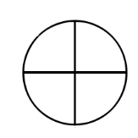
$1-\frac{1}{4}=$ $1-\frac{3}{4}=$

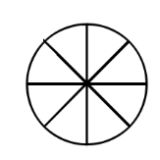
$1-\frac{1}{8}=$ $1-\frac{5}{8}=$

$1-\frac{15}{16}=$

The Number Line Revisited
Where is a whole on the number line? Where are fractions on a number line?
A number line has to have the same distance between the same amounts, but we can make them to different “scales.” Like a ruler, we can split one whole into parts. A whole is 1
0
1

To divide it into 2 parts, we need one line, right in the middle.

$$\frac{1}{2}+\frac{1}{2} =\frac{2}{2}= 1$$

$$\frac{1}{2}$$

$$\frac{1}{2}$$

If we want to divide the whole unit into 3 equal parts, we need two marks equally spaced.
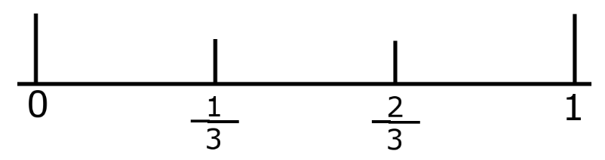
$$\frac{1}{3}$$

$$\frac{1}{3}$$

$$\frac{1}{3}$$

$$\frac{1}{3}+\frac{1}{3}+\frac{1}{3}=\frac{3}{3}=1$$

Example 7: Draw a whole on this number line. Divide it into 8 equal parts and label it.
Mark these two number lines to show that ¼ is less than ½.
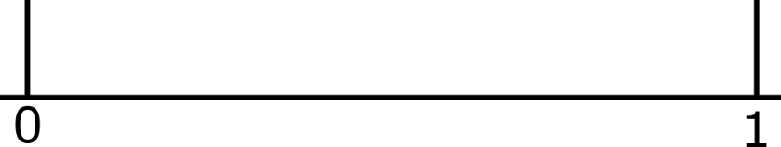

Are all proper fractions less than one? ___________
Are all improper fractions more than one? ________
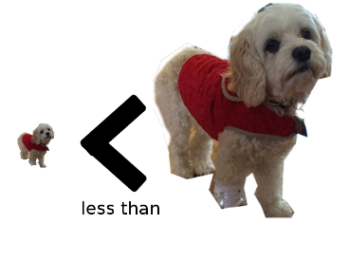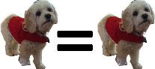
Fill in each blank with < , > , or = to make a true statement:
- 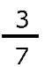 ___ 1 | - 1 _____ $\frac{6}{5}$
- 1 _____ $\frac{9}{10}$ | - $2/3$ _____ 1
- $\frac{13}{10}$ _____ 1 | - 1 _____ $\frac{7}{7}$
- 1 ______ $\frac{5}{5}$ | - $\frac{5}{3}$ ______ 1

Section 3.2 Homework part 1 Name____________________

- Compute each of the following and simplify your answer whenever possible:

- $\frac{2}{9}$ + $\frac{7}{9}$ g) $\frac{2}{6}$ + $\frac{4}{6}$ m) 1 - $\frac{4}{15}$

- 1 - $\frac{3}{4}$ h) 1 - $\frac{3}{10}$ n) $\frac{0}{7}$ + $\frac{5}{7}$

- $\frac{3}{7}$ + $\frac{4}{7}$ i) $\frac{6}{10}$ + $\frac{4}{10}$ o) 1 - $\frac{99}{100}$

- 1 - $\frac{11}{20}$ j) 1 - $\frac{9}{11}$ p) $\frac{0}{6}+ \frac{1}{6}+ \frac{2}{6}+ \frac{3}{6}$

- $\frac{4}{9}+ \frac{5}{9}$ k) $\frac{5}{8}+ \frac{3}{8}$ q) $\frac{1}{5}+ \frac{1}{5}+ \frac{1}{5}$

- 1 - $\frac{1}{3}$ l) $\frac{1}{4}+ \frac{1}{4}+ \frac{2}{4}$ r) $1- \frac{1}{8}- \frac{2}{8}$

- Fill in each box with <, >, or = to make a true statement:

- $\frac{4}{3}$ 1 i) $\frac{x}{x}$ $\frac{4}{3}$ q) $\frac{1}{a}$ $\frac{0}{a}$

- 1 -$\frac{2}{5}$ $\frac{1}{5}$ j) 1 - $\frac{1}{2}$ $\frac{1}{2}$ r) $\frac{4}{7}+ \frac{3}{7}$ $\frac{5}{3}$

- $\frac{4}{5}$ 1 k) $\frac{x+1}{x+1}$ $\frac{x-1}{x-1}$ s) $\frac{1}{5}$ $\frac{1}{2}$

- $\frac{2}{9}$ $\frac{9}{2}$ l) 1 - $\frac{5}{8}$ $\frac{3}{8}$ t) $\frac{10}{10}$ 1 - $\frac{1}{10}$

- $\frac{2}{3}$ 1 m) $\frac{x+1}{x+1}$ $\frac{4}{3}$ u) $\frac{y}{y}$ $\frac{0}{y}$

- $\frac{0}{x}$ $\frac{1}{5}$ n) $\frac{1}{2}$ $\frac{1}{3}$ v) $\frac{m}{m}$ $\frac{5}{3}$

- $\frac{7}{3}$ 1 o) $\frac{3}{3}$ $\frac{2}{2}$ w) $\frac{6}{5}$ 1

- $\frac{5}{9}$ $\frac{9}{5}$ p) $\frac{2}{2}$ $\frac{3}{5}$ x) $\frac{11}{10}$ 1

- Locate (with marks) and label $\frac{1}{5} , \frac{2}{5} , \frac{3}{5} and \frac{4}{5}$ on this number line. I want your answer to be fairly accurate, so take your time (and use pencil so you can change it if you need to).

__________________________________________________________

- 1

- Locate (with marks) and label $\frac{1}{3} and \frac{2}{3}$ on this number line. I want your answer to be fairly accurate, so take your time.

__________________________________________________________

0 1

- Locate (with marks) and label $\frac{1}{6}, \frac{2}{6}, \frac{3}{6}, \frac{4}{6} and \frac{5}{6}$ on this number line. I want your answer to be fairly accurate, so take your time.

_____________________________________________
- 1

Section 3.2 Homework - Part 2 Name__________________________

- Locate (with marks) and label $\frac{1}{5} , \frac{2}{5} , \frac{3}{5} and \frac{4}{5}$ on this number line. I want your answer to be fairly accurate, so take your time (and use pencil so you can change it if you need to).

__________________________________________________________

- 1

- Locate (with marks) and label $\frac{1}{3} and \frac{2}{3}$ on this number line. I want your answer to be fairly accurate, so take your time.

__________________________________________________________

0 1

- Locate (with marks) and label $\frac{1}{6}, \frac{2}{6}, \frac{3}{6}, \frac{4}{6} and \frac{5}{6}$ on this number line. I want your answer to be fairly accurate, so take your time.

_____________________________________________
- 1

- Locate and label $\frac{1}{2}$ on each of the three number lines above.

- Fill in each box with <, >, or = to make a true statement:

- $\frac{2}{3}$ 1 e) $\frac{x+1}{x+1}$ $\frac{4}{3}$ i) $\frac{y}{y}$ $\frac{0}{y}$

- $\frac{0}{x}$ $\frac{1}{5}$ f) $\frac{1}{2}$ $\frac{1}{3}$ j) $\frac{m}{m}$ $\frac{5}{3}$

- $\frac{7}{3}$ 1 g) $\frac{3}{3}$ $\frac{2}{2}$ k) $\frac{6}{5}$ 1

- $\frac{5}{9}$ $\frac{9}{5}$ h) $\frac{2}{2}$ $\frac{3}{5}$ l) $\frac{11}{10}$ 1

