Chapter 3 Fractions 2026
Section 3.1 Introduction
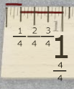
What is a fraction? A fraction is a part of a whole. If we say that someone grew a fraction of an inch, we mean they grew a part of an inch. If we say we have just read a fraction of a book, we mean we have only read part of it. Fractions measure how big or small that part is.

A fraction is a number in the form $\frac{a}{b}$, where b is never allowed to be zero.
The denominator of a fraction is the number on the __________________________. The denominator tells us how many equal parts the whole is divided into.
The numerator of a fraction is the number on the ____________. The numerator tells us how many parts we have.
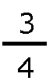
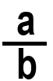
numerator
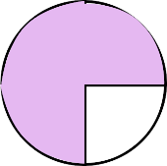
denominator

Example 1
We want to describe what part of a fraction was eaten. Let’s assume the pizza was cut into eight equal pieces: that the denominator is eight. The three pieces were eaten, so the numerator is three. We say that $\frac{3}{8}$ of the pizza was eaten.
This makes sense because each piece of pizza is $\frac{1}{8}$ of the pizza. Three pieces is
$\frac{1}{8}+\frac{1}{8}+\frac{1}{8}=\frac{3}{8}.$ 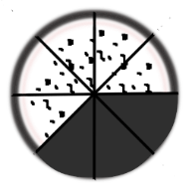
What fraction of the pizza was not eaten? ____________________________
You could count them – or realize that $\frac{8}{8}-\frac{3}{8} =\frac{5}{8}$
Example 2:
We want to describe what part of a birthday cake is left. If the cake was cut into 12 equal pieces (3 rows of 4), then the denominator is 12. If 5 pieces of cake are left, then the numerator is 5. So $\frac{5}{12}$ of the cake is left.
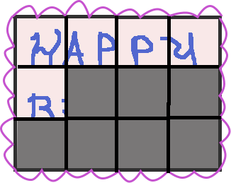

$\frac{12}{12}$ is the whole cake.
What fraction of the cake was eaten? _______________________
Example 3 – no pictures!!!
- Books are divided into equal parts – pages. What fraction of a book have you read if the book has 100 pages and you’ve read 53 of them?
Example 4
- In a class of 20 students, 17 of them live close enough to ride their bikes to get there. What fractional part live close enough?

- What fractional part DON’T live close enough to ride their bikes?

What if a pizza was cut into 8 pieces and all of the pieces were eaten? That means the whole pizza was eaten, not just a part. If 8 pieces out of 8 pieces were eaten, that would be 8/8 of the pizza. Since this is a whole pizza, not really a part, we call it an improper fraction.
A proper fraction is one in which the ______________________ is less than the ____________________________.
An improper fraction is one in which the _____________________ is greater than or equal to the _________________________.
Example 5:
Circle the proper fractions:
$$\frac{2}{3}, \frac{4}{4} , \frac{1}{ 6} , \frac{5}{9}, \frac{10}{8}$$

Example 6: Circle the improper fractions
$$\frac{4}{2}, \frac{8}{10} , \frac{ 1}{2} , \frac{5}{4}, \frac{6}{7}$$
8/8 is a whole pizza. 12/12 is a whole cake. What are three or four other fractions that are equivalent (another way of saying) to a whole? Be creative!!!
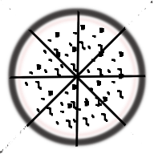

Special fractions:
$\frac{a}{a}=1$ $\frac{a+b}{a+b}=1$ $\frac{-a}{-a}=1$

$\frac{a}{1}= a$ $\frac{0}{a}=0$
(Remember, the denominator can never be zeo!)
$\frac{a}{a}=1$ $\frac{a}{1}= a$ $\frac{3}{1}= 3$
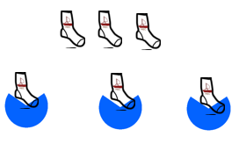
$\frac{5}{1}= 5$ 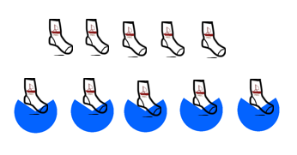
ANSWER THESE
$\frac{0}{2}= _____$ $\frac{2}{2}= _____$
$\frac{0}{5}= 0$ 
$\frac{7}{1}= _____$ $\frac{13}{1}= _____$
$\frac{a+m}{a+m}= _____$ $\frac{0}{w}=$

COMPARING FRACTIONS
Which is bigger, $\frac{1}{3}$ or $\frac{1}{7}$ ? Divide the “whole” boxes into sections.

How many lines did you have to draw to split it into thirds? _______
How many lines did you have to draw to split it into sevenths? _______
Which is bigger, $\frac{1}{2}$ or $\frac{1}{4}$ ? Divide the circles into those fractions. BONUS: can you split a circle into 5 approximately even pieces?
v

Example 8: Fill in each blank with < or > to make a true statement. Complete a picture that supports your answer.
- $\frac{1}{4}$ ____$\frac{1}{10}$

- $\frac{1}{6}$ ____$\frac{1}{2}$
v
v

$\frac{1}{5}$ ____$\frac{1}{8}$

Answer Key:
Page 1: The denominator is on the bottom; the numerator is on the top. 5/8 of the pizza was not eaten.
Page 2: 7/12 of the cake, 53/100 of the book, 17/20 and 3/20 of the class.
Page 3: numerator is less than denominator: proper
Numerator greater than or equal to denominator: improper
proper: 2/3, 1/6, 5/9
Improper: 4/2, 5/4
Page 4: $\frac{0}{2}= 0$ $\frac{2}{2}= 1$ $\frac{7}{1}= 7$ $\frac{13}{1}= 13$
$\frac{a+m}{a+m}= 1$ $\frac{0}{w}= 0$
- $\frac{1}{4}$ >$\frac{1}{10}$

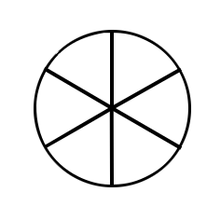
- $\frac{1}{6}$ < $\frac{1}{2}$
v

C) $\frac{1}{5}$ > $\frac{1}{8}$

